Julian Burgoff

11/7/2022

Analysis of Environmental Data

Lab 8

1. require(palmerpenguins)

penguin_dat= droplevels(subset(penguins, species != 'Gentoo'))

install.packages("simpleboot")

require(simpleboot)

adelie= subset(penguin_dat, species == 'Adelie')

chinstrap= subset(penguin_dat, species== 'Chinstrap')

pen_boot= two.boot(adelie$flipper_length_mm, chinstrap$flipper_length_mm, mean, R= 10000, na.rm= TRUE)

sd(pen_boot$t)

[1] 1.0047

1. 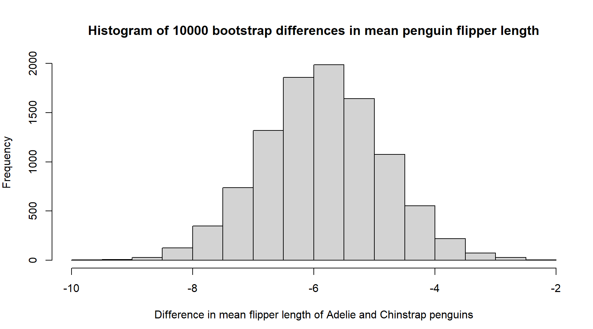
2. quantile(pen_boot$t, c(0.025, 0.975))

2.5% 97.5%

-7.819310 -3.874961

1. The bootstrap resampled differences in means are pretty normally distributed as seen in the histogram, where the highest frequencies are right around -6 declining fairly evenly on both sides of the histogram. Both the mean and median are almost identical (both right around -5.85) which further supports the claim that these data are normally distributed.
2. pen_ecdf= ecdf(pen_boot$t)
3. 1- pen_ecdf(-4.5)

[1] 0.0872

1. pen_ecdf(-8)

[1] 0.0161